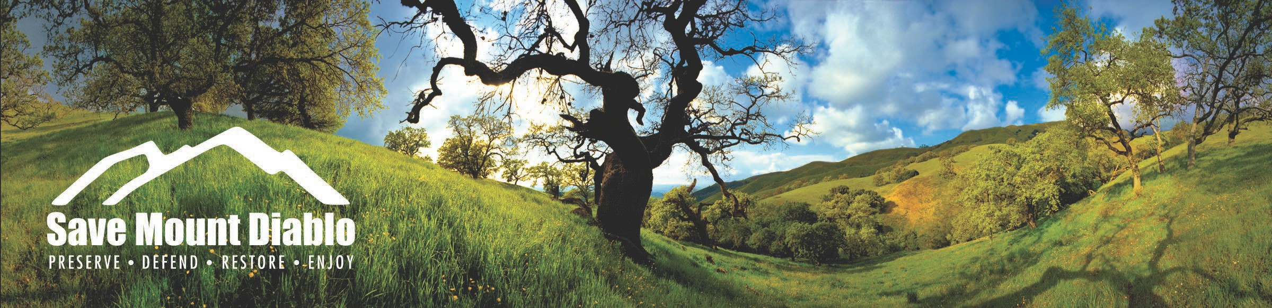

Mary Bowerman Science and Research Program

2023-2024 Grant Guidelines & Application

Overview

The Mount Diablo wilderness is an ecological “hot spot” for many reasons. Diablo’s location and rugged topography include an array of exposures with influences from the coast, the Central Valley, and the Delta. These microclimates combine with unique geology to create high levels of biodiversity and endemism. The mountain is also the single most important wildlife habitat area in the East Bay. Mount Diablo is home to at least 253 vertebrate animal species and over 900 plant species, three-quarters of which are native. More than 150 species are rare or listed and eleven known species are endemic to the Mount Diablo region.

Save Mount Diablo's (SMD) mission is to preserve Mount Diablo's peaks, surrounding foothills and watersheds through land acquisition and preservation strategies designed to protect the mountain's natural beauty, biological diversity, and historic and agricultural heritage. SMD also strives to enhance our area's quality of life by providing recreational opportunities consistent with the protection of natural resources. SMD seeks to improve our understanding of the Mount Diablo wilderness through scientific research in honor of our co-founder, Dr. Mary L. Bowerman.

Dr. Bowerman co-founded Save Mount Diablo in 1971. Dr. Bowerman was a botanist and a student of the flora and vegetation of Mount Diablo for over seventy years. She received her PhD from the University of California at Berkeley and authored The Flowering Plants and Ferns of Mount Diablo, California; Their Distribution and Association into Plant Communities, The Gillick Press, 1944. The Mary Bowerman Science and Research (MBSR) Program provides small grants, especially to students, for research projects on Save Mount Diablo properties and the network of protected lands in the Mount Diablo region. Grants of up to $2,500 will be awarded to applicants who are conducting studies that will enhance the ecological understanding of the region and inform land management and conservation practices.

In addition to research on the mountain, the goal of the MBSR program is to share data with the general public. SMD hosts an annual Mary Bowerman Science and Research Colloquium in which grant recipients and other researchers working on the mountain present their findings. This event informs other scientists, researchers, and interested public attendees about discoveries on the mountain. It is SMD’s hope that the stories and findings emanating from the MBSR Grant Program will reach new audiences, spark interest in the community, and inspire more visitors and researchers to the Mount Diablo Region.

Eligibility

SMD seeks project proposals from all scientific disciplines that may contribute to the ecological understanding of the Mount Diablo Region. Projects may be of any length or scope; grants can be renewed several times each year. Grant recipients are expected to present an update and/or submit findings at the annual research meeting held each December. Projects should be affiliated with an academic, non-profit, or professional scientific entity.

Projects must be located within the northern Diablo Range from Mount Diablo and its foothills, east of Interstate 680 and west of the Central Valley (to the Byron Highway), extending through the Altamont Pass into the Diablo Range to Pacheco Pass (Hwy 152).

Grant Application

Please use the application form provided by SMD. Be sure to include any permits, maps, or other pertinent attachments that will better inform the grant awarding process.

Recommended attachments

- Map of your project location(s)
- Designs or illustrations that clearly shows the project you are proposing to do

Project Budget

Your budget should list each separate item for which you are requesting funds with the corresponding cost. The maximum award amount for each project will be $2,500. If you are requesting a portion of your total project cost, please provide your budget for the total project as well and indicate if funds have been secured or what your plan is for securing needed funds.

Authorizations

If your project takes place on another organization’s property, you must have approval from that organization prior to receiving the grant award. Full approval is not needed prior to this application.

You must have approval of California State Parks to conduct your project on their property:

Gina Benigno
Senior Environmental Scientist, Specialist
California State Parks Diablo Range District
Ph: 925-409-8392
Gina.Benigno@parks.ca.gov
You must have approval of East Bay Regional Park District to conduct your project on their property:
Anita Slater
Stewardship Department
2950 Peralta Oaks Court Oakland, CA 94605
Ph: (510) 544-2363
aslater@ebparks.org

You must have approval of Contra Costa Water District to conduct your project on their property:

Contra Costa Water District
Los Vaqueros Watershed and Conservation Lands
P.O. Box H2o Concord, CA 94524
Attention: Real Property Division Ph: 925-240-2360 or 925-240-2361

***If you are interested in accessing SMD property and your project is approved, you will be assigned an SMD staff member who can approve your access needs to complete your project.

Application Process

- Submit the completed application by email as a single Adobe PDF.
- Email completed applications to Sean Burke at sburke@savemountdiablo.org. You will receive a confirmation of your application from Sean within one or two business days.

Awards

The maximum amount of each award will be $2,500.

Return by email to: Sean Burke, sburke@savemountdiablo.org

Applications will be considered by the Mary Bowerman Science & Research Committee.
Deadline for applications is December 1st, 2023

Mary Bowerman Science and Research Program

2023-2024 Grant Application Form
Please read the guidelines before completing this form.

Date Submitted:
Name of project: Location(s) of project: Duration of project: Name of Researcher(s): Affiliation:
Contact Address: ZIP Code
Daytime or mobile Phone: Email: Name of advisor (if applicable):
Please answer the following questions. Suggested total length is 1-3 pages.

- Describe your proposed project including the research objective and methods.
- Describe what type of land access you need including location; frequency and duration (if you are not sure, please indicate that you would like help selecting your research location(s)).
- Describe how you anticipate your research will contribute to the ecological understanding of the Mount Diablo area.
- Note any challenge or questions you have that would need to be resolved before you can conduct your project.
- Include a description of any collaborators or partners and a short biography of the lead applicant.
- If additional funds are required outside of this grant, please describe what funds have been secured and what funds are needed, along with a plan to secure the missing funds (if applicable).

Summarize the project budget below. Add lines as needed. List each item separately.

Item description | SMD grant amount | Other project expenses
TOTAL

Return by email to: Sean Burke, sburke@savemountdiablo.org

Deadline for applications is December 1st, 2023

